HOW TO UPLOAD OFFICIAL UNJSPF FORMS AND SUPPORTING DOCUMENTS IN YOUR MEMBER SELF SERVICE ACCOUNT
TO REGISTER
- Click the link below

https://member.unjspf.org/v3prod/app?service=page/MemberPages:MemberLogin
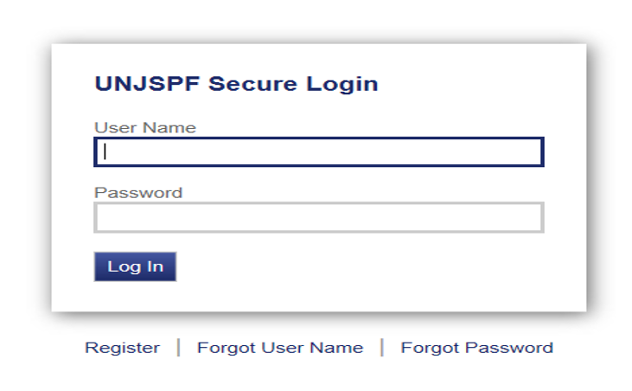
- Enter your User Name and Password and click LOG IN
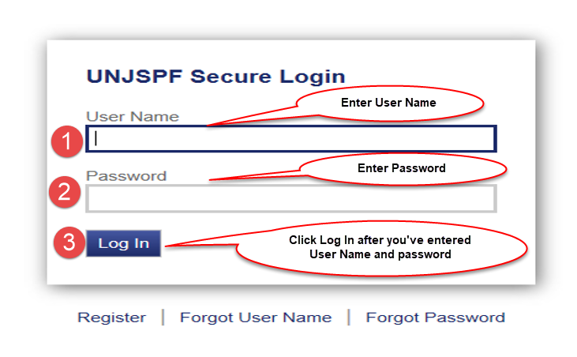
- Click “MSS Document Upload” tab and after reading the instructions on how to submit Official UNJSPF Forms and supporting documentation click “Send Message” tab.
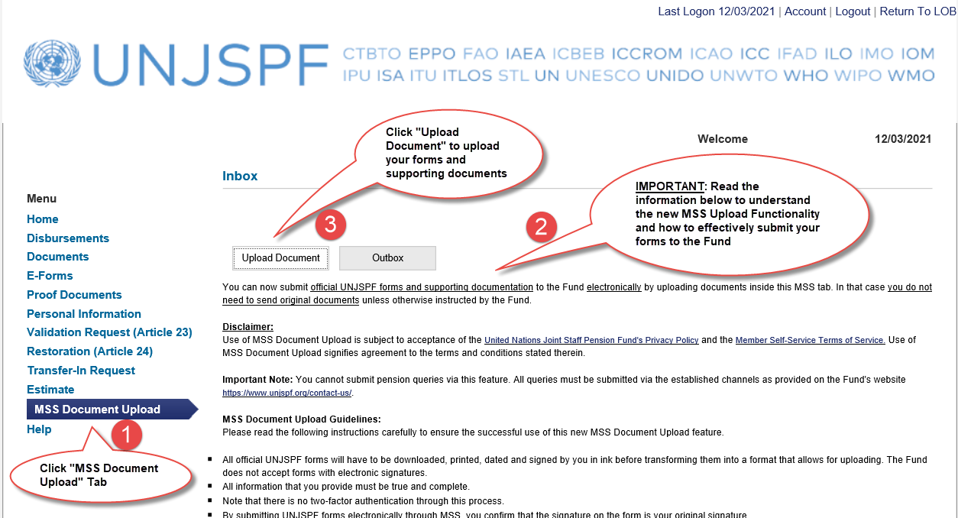

- Click on BROWSE to select form/supporting documents (you should have already completed, scanned and saved the copy first) and then click on UPLOAD.
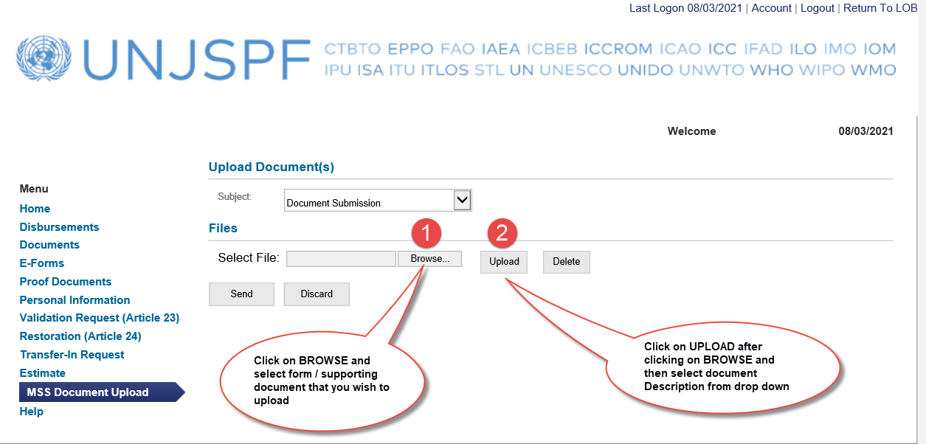

- Select Form Type from the “Description Menu” drop down list after uploading form/supporting documents. If you wish to UPLOAD more than one document, repeat the process by clicking on BROWSE then select additional document you wish to upload and then click on UPLOAD.
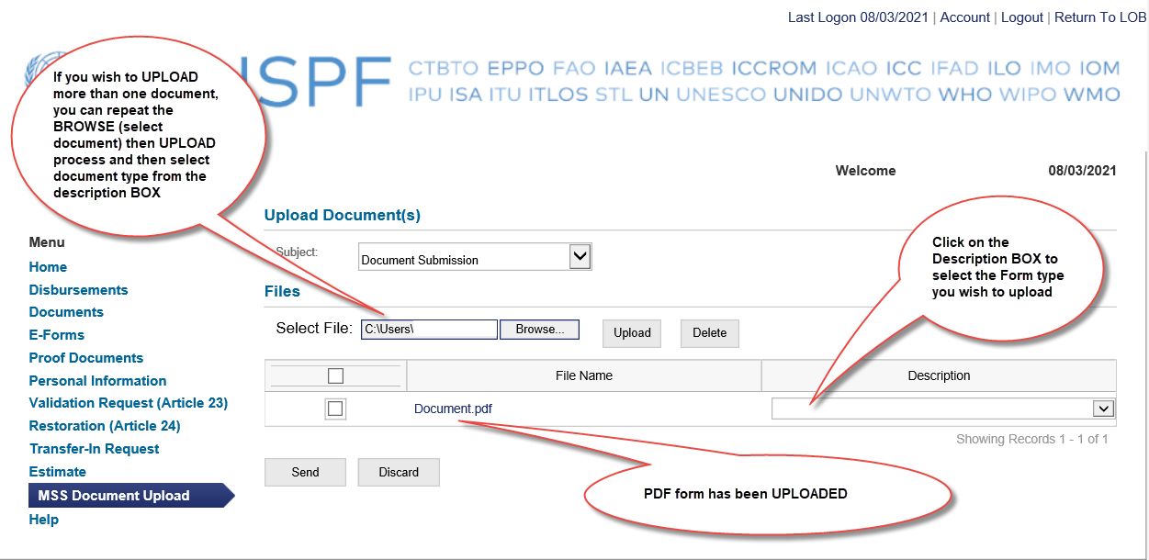

- Select the document description from the Dropdown Menu. If no description fits your document, please select “Other”

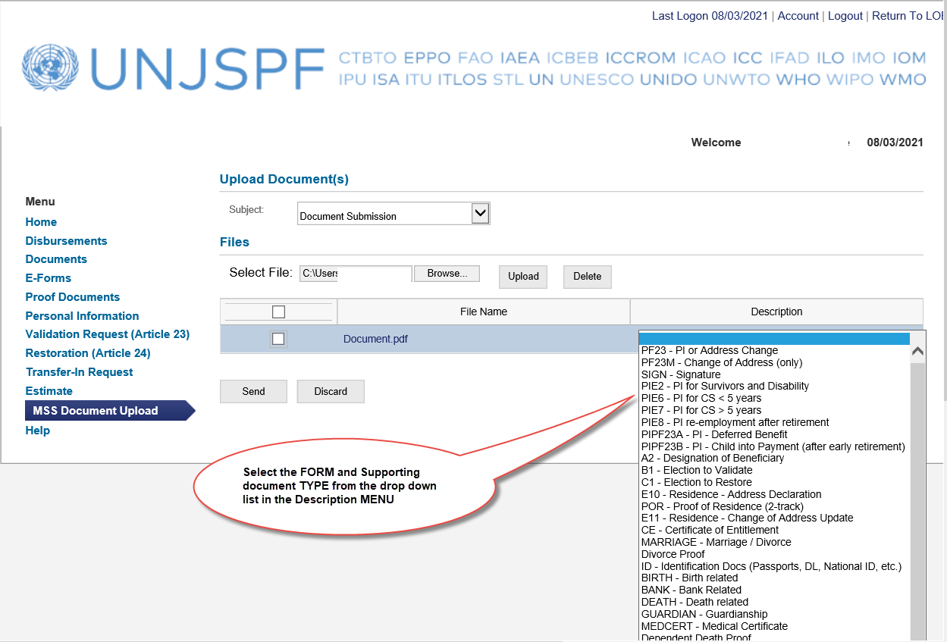

- After uploaded documents, click on SENT

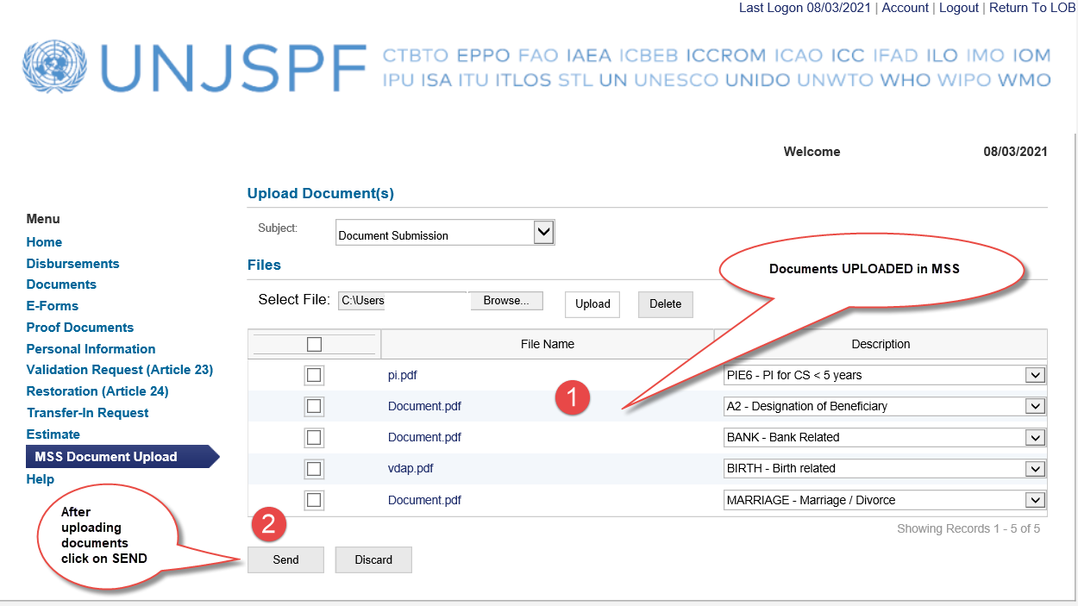

- Confirmation of Message Transmission

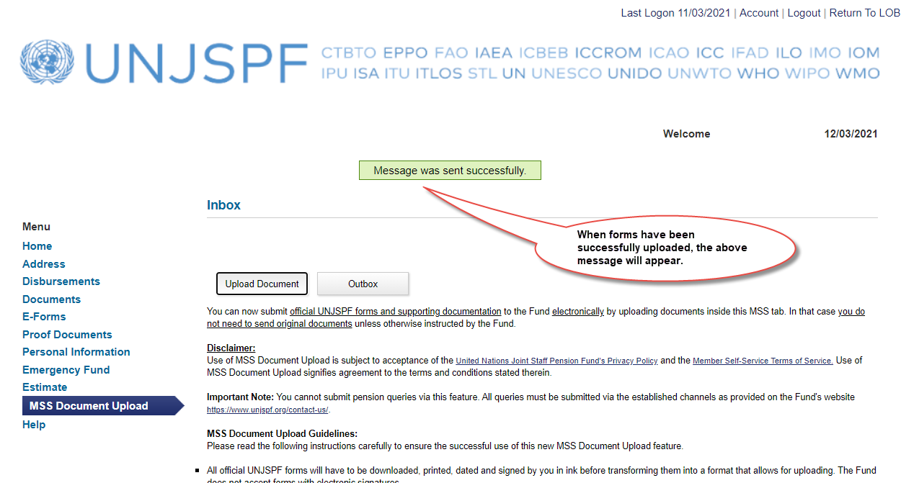

- How to see message and uploaded documents you sent: click on OUTBOX

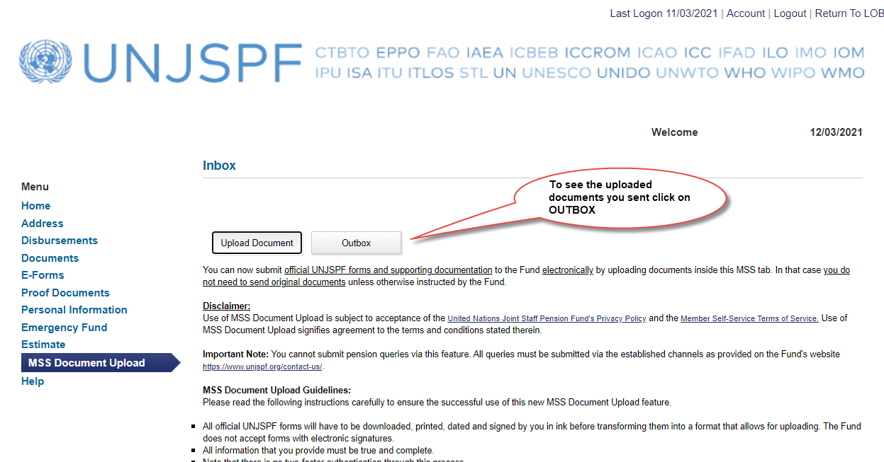

- Looking at the Message Details on the Outbox

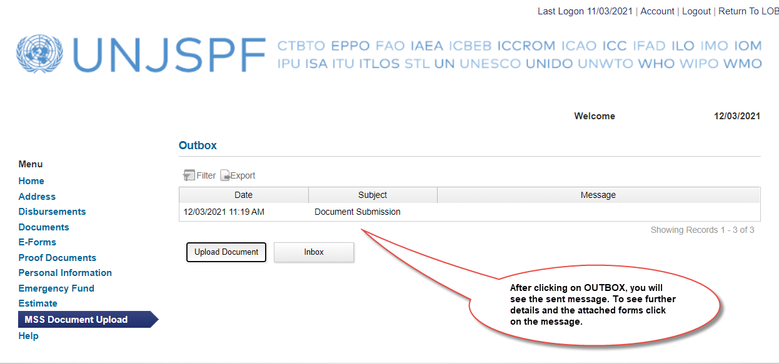

- The MSS User can open the attachments in Outbox, but cannot remove or delete them, or change the description. Click on the BACK Button to return to the Outbox summary view.

